# Choose your upgrade journey from Skype for Business to Teams

<https://docs.microsoft.com/fr-fr/microsoftteams/upgrade-and-coexistence-of-skypeforbusiness-and-teams>

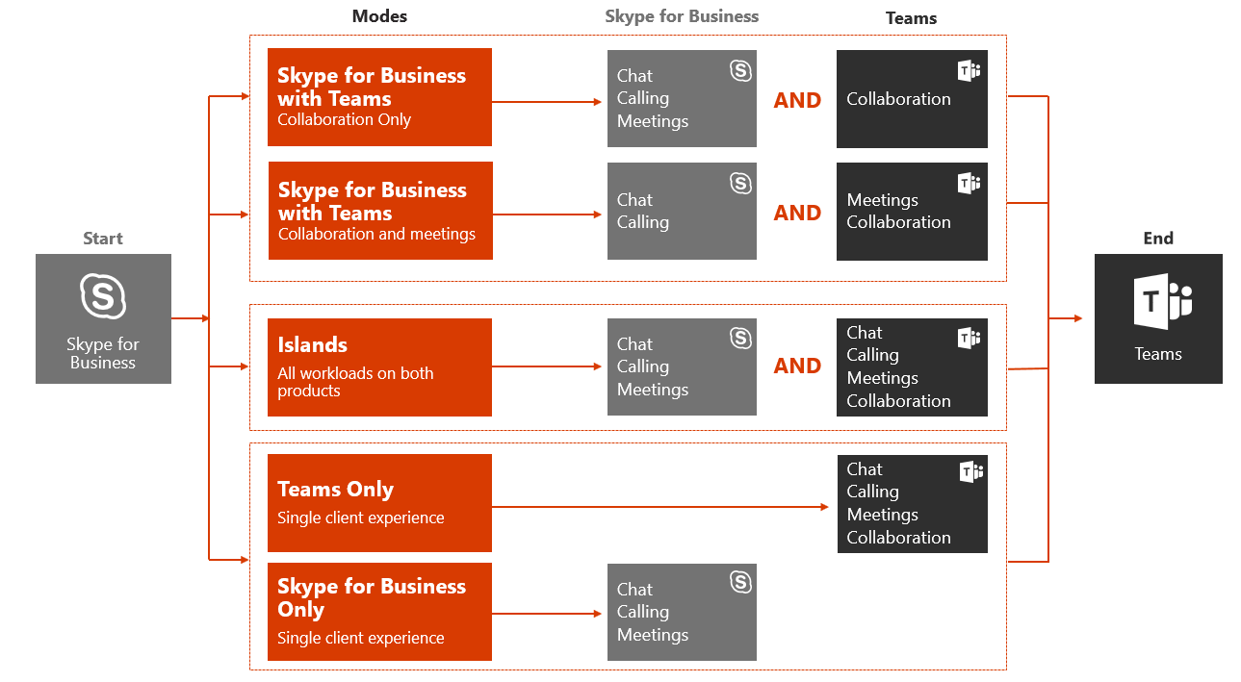



This article is part of Deployment and Implementation stage of your upgrade journey. Before proceeding, confirm that you’ve completed the following activities:

* [Enlisted your project stakeholders](https://docs.microsoft.com/fr-fr/microsoftteams/upgrade-enlist-stakeholders)
* [Defined your project scope](https://aka.ms/SkypetoTeams-Scope)
* [Understood coexistence and interoperability of Skype for Business and Teams](https://aka.ms/SkypeToTeams-Coexist)

# Choose your upgrade journey from Skype for Business to Teams

As an existing Skype for Business customer, your complete transition to Teams might take some time. However, you can begin realizing the value of Teams today, by enabling your users to use Teams alongside Skype for Business. Given that there’s some overlapping functionality between the two apps, we recommend that you review the available coexistence and upgrade modes to help determine which path is right for your organization. For example, you might opt to enable all workloads on both solutions without interoperability. Or, you might decide to manage the user experience, either by gradually introducing Teams capabilities or by targeting groups of users for select capabilities, until your organization is ready to upgrade everyone to Teams. Use the outcome of your pilot to help assess the right upgrade journey for your organization.

Important

This article outlines the various modes that enable you to manage which modalities in Skype for Business and Teams are available to your users. As with any deployment, we strongly encourage you to [pilot your intended plan](https://docs.microsoft.com/fr-fr/microsoftteams/pilot-essentials) with a selected group of users before upgrading your organization to Teams. Remember, introducing new technology can be disruptive for users. Take time to assess user readiness and implement a communication and training plan prior to implementing any of the modes outlined herein.

## Upgrade journey building blocks

To formally prepare your organization for its journey to Teams, you need to start planning for the upgrade scenarios that will eventually let your organization fully embrace Teams as your sole communications and collaboration solution.

To help guide your decision-making process, familiarize yourself with the various modes, concepts, and terminology relevant to upgrading from Skype for Business to Teams. For more information, see [Microsoft Teams and Skype for Business coexistence and interoperability](https://aka.ms/SkypeToTeams-Coexist)

When some of your users are ready to use only Teams for their day-to-day communications and collaboration needs, you can start upgrading these users to Teams by enabling **Teams Only** mode for them.

If it’s not feasible for your whole organization to move to Teams, you can start by piloting Teams alongside Skype for Business in **Islands** coexistence mode. As the additional coexistence modes, (i.e. **Skype for Business with Teams collaboration** and **Skype for Business with Teams collaboration and meetings**), are become progressively fully available in the next few months, you can also start by fully adopting Teams as a group collaboration solution first while keeping Skype for Business as your organization’s unified communications solution. That is Microsoft’s recommended path for customers using Skype for Business Server (on-premises or hybrid) and customers with significant complexity whose trajectory to Teams will include a long coexistence period.



The following table compares coexistence and upgrade modes.

| **Mode** | **Situation** | **Recommended Use** | **Advantages** | **Caveats** |
| --- | --- | --- | --- | --- |
| Islands | Smaller or simpler Skype for Business deployment  Ability and willingness to manage some short-term complexity to move to Teams more quickly | Go to the full Teams experience as quickly as possible  Conduct a proof of concept (PoC) of Teams  Recommended upgrade path for organizations who adopted Skype for Business Online | Simple to operate  Richest Teams experience up-front for all capabilities | Requires good user communication to avoid confusion and to drive usage toward Teams  Exit strategy requires users to have fully adopted Teams prior to starting upgrade to Teams Only phase  No interop for users in Islands mode; also no federation from Teams when the user’s Skype for Business account is homed on-premises |
| Skype for Business with Teams collaboration | Skype for Business deployment with requirements that aren’t yet met by Teams (for example, advanced compliance)  Long-term need for and/or commitment to Skype for Business | Start Teams adoption quickly, focusing on group collaboration first  Want to keep all unified communications workloads on Skype for Business for now  Recommended use as the starting point for organization starting their journey from on premises (or hybrid) Skype for Business | No overlapping capabilities between Teams and Skype for Business  Instant messaging chat and meeting scheduling will reside in Skype for Business (tied to calling)  Interoperability with users in Teams Only |  |
| Skype for Business with Teams collaboration and meetings | Skype for Business deployment with significant use of enterprise voice and requirements that aren’t yet met by Teams calling  Long-term need for and/or commitment to Skype for Business  Might be using a third-party meeting service | Start Teams adoption quickly, going beyond group collaboration  Improve your users’ meetings experience  Recommended use for on premises organizations wanting to take advantage of Teams meetings prior to being ready to fully upgrade (generally due to Enterprise Voice on-premises). | No overlapping capabilities  Superior meetings on Teams. Features roadmap, UX and cross platform, quality and reliability  "Better Together" experiences between Skype for Business and Teams  Interoperability users in Teams Only. | Instant messaging and chat will reside in Skype for Business (tied to calling) |
| Teams Only | Some users need to stay on Skype for Business  You’re upgrading your Skype for Business Online users to Teams while keeping Skype for Business on-premises users on Skype for Business Server  You might have already deployed users in islands mode and are ready to retire Skype for Business for groups of users | Reduce variable costs on Skype for Business (on-premises server operations, outsourcing contract, and so on)  Go to the full Teams experience as quickly as possible, for at least some users | Limits user confusion by providing only one client to work with Interoperability with users in Skype for Business Only, Skype for Business with Teams Collaboration, Skype for Business with Teams Collaboration and Meetings | Interoperability only supports basic chat and calling between Skype for Business and Teams, and interop escalation scenarios for desktop sharing and multi-party chat and calling |
| Skype for Business only | Some users need to stay on Skype for Business | Limits user confusion by providing only one client to work with  User can still participate in Teams meetings they are invited to | Continue to meet business requirements that currently can only be met by Skype for Business  Interoperability with users in Teams Only | Interoperability only supports basic chat and calling between Skype for Business and Teams, and interop escalation scenarios for desktop sharing and multi-party chat and calling |

## Upgrade journeys

You can take multiple approaches to upgrading from Skype for Business, either online or on-premises, to Teams:

* In a direct upgrade journey, you first deploy Teams alongside Skype for Business in **Islands** mode as part of evaluation and early adoption, and then upgrade your users to **Teams Only** mode with the goal of quickly retiring Skype for Business from the environment for all users in the organization. This is the recommended journey for Skype Business online customers, unless they are concerned their users will be confused with having two tools to conduct the same action (chat, calling, meeting scheduling).
* A gradual upgrade journey delivers a specific coexistence and upgrade mode to a specific group of users (also called a cohort), depending on their communications and collaboration requirements. Over time, the entire organization can converge into using Teams Only and eventually replace Skype for Business. However, if your organization has compelling business reasons to keep Skype for Business—such as a dependency on a Unified Communications Managed API (UCMA)–based solution that integrates with line-of-business applications, or an ethical wall solution currently available for Skype for Business only, or a complex Enterprise Voice deployment that will take time to upgrade to **Teams Only**—you can upgrade a portion of users to **Teams Only** mode while retaining Skype for Business users in one of the coexistence modes for a portion of your user population. Gradual upgrade journey is the recommended approach for on-premises (and hybrid) customers starting with Skype for Business with Teams Collaboration coexistence mode and moving from there to Teams Only mode when requirement for the users met (possibly through the Skype for Business with Teams Collaboration and Meetings coexistence mode).

Important

For both types of upgrade journey, if your organization is currently a Skype for Business on-premises deployment only, you need to start planning to implement Skype for Business hybrid before upgrading your users to **Teams Only** mode. This will also help facilitate interoperability with Teams.

Use [MyAdvisor](https://myadvisor.fasttrack.microsoft.com/) to guide your Skype for Business hybrid implementation.

Notes

**Teams Only** mode requires that the users who are part of cohorts be homed in Skype for Business Online, and a hybrid relationship between your Skype for Business on-premises deployment and your Skype for Business Online tenant is required to facilitate the interoperability between Skype for Business and Teams. The move to Skype for Business Online must be completed for users who are part of the cohorts before they’re upgraded to **Teams Only** mode. Skype for Business Server 2019, and Skype for Business Server 2015 with CU8 update can simplify the mechanics of upgrading on-premises users to Teams by managing the migration to Skype for Business Online and upgrading the users to **Teams Only** mode in one step.

### Direct upgrade journey

The direct upgrade journey is illustrated in the following diagram.

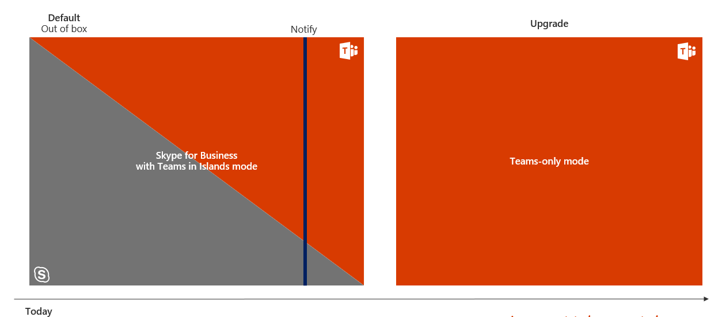

Teams is deployed to all users in the organization and configured in **Islands** mode. When your organization determines that Teams is ready to fulfill all of your communications and collaboration needs, notify the users and upgrade them to **Teams Only** mode. At that point, Skype for Business can be retired from the environment.

### Gradual upgrade journey

An example of a gradual upgrade journey is illustrated in the following diagram.

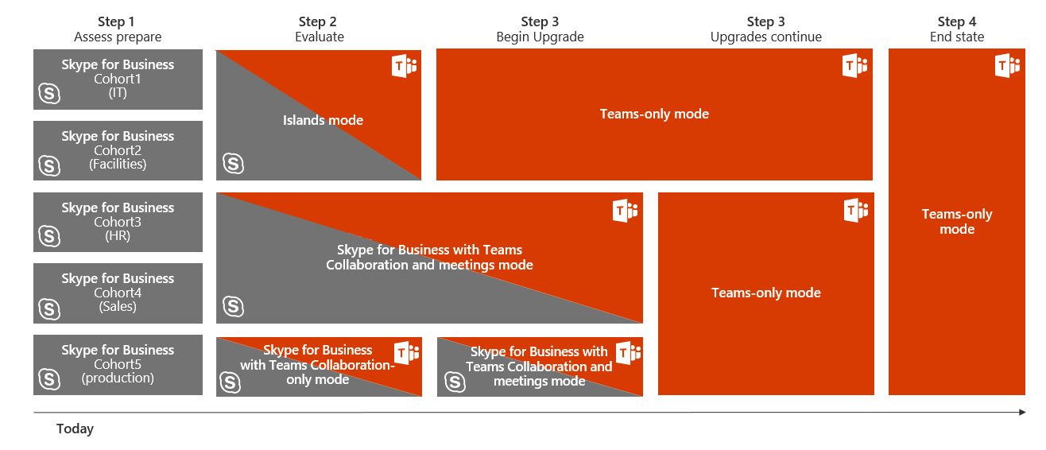

Teams is deployed in the organization in **Islands** mode for evaluation and then move to different coexistence and upgrade modes for different groups of users. For example, a group of users can be enabled for **Islands** mode, another enabled for **Skype for Business with Teams collaboration and meetings** mode, while a third group of users might initially be enabled for **Skype for Business with Teams collaboration only** mode.

Over time, groups of users can be upgraded to **Teams Only** mode, followed by the rest of the organization. Eventually, the entire organization will be ready to retire Skype for Business and use only Teams for communications and collaboration, or—if business requirements dictate that Skype for Business be retained for a specific group—the majority of users in the organization can use Teams Only.

|  |  |  |
| --- | --- | --- |
| https://docs.microsoft.com/fr-fr/microsoftteams/media/audio_conferencing_image7.png Decision point | Which upgrade journey is suitable to your organization's business requirements? | |
| https://docs.microsoft.com/fr-fr/microsoftteams/media/audio_conferencing_image9.png Next step | Identifying your current deployment model, use case scenarios, and key considerations for your organization will inform the journey to Teams that’s best suited to your organization. | |
| https://docs.microsoft.com/fr-fr/microsoftteams/media/audio_conferencing_image7.png Decision point | | Which upgrade scenario is applicable to your organization? |
| https://docs.microsoft.com/fr-fr/microsoftteams/media/audio_conferencing_image9.png Next steps | | Decide the timeline of your organization's upgrade journey based on messaging, meetings, and calling business requirements.  Decide the required additional work to complete your upgrade journey. |

After you’ve chosen the best upgrade journey for your organization, [perform your upgrade to Teams](https://aka.ms/SkypeToTeams-Upgrade).

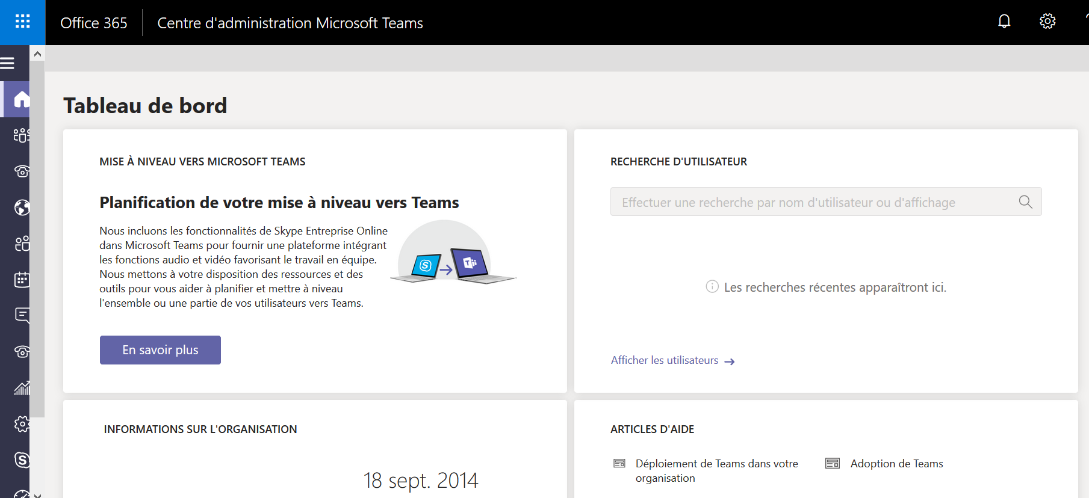

<https://docs.microsoft.com/fr-fr/microsoftteams/setting-your-coexistence-and-upgrade-settings>

# Configuration de vos paramètres de coexistence et de mise à niveau

* 07/03/2019
* 8 minutes de lecture
* Contributeurs
  + [Tony Smith (MSFT)](https://github.com/tonysmit)
  + [](https://github.com/olprod)
* S’applique à:

Microsoft Teams

Important

Le nouveau centre d’administration Microsoft Teams est désormais disponible ! Depuis le mois de mars 2018, nous y migrons progressivement les paramètres du centre d'administration de Skype Entreprise actuel et de l’expérience Microsoft Teams dans le centre d’administration Office 365. Quand un paramètre est migré, une notification s’affiche et vous êtes dirigé vers son emplacement dans le nouveau centre d’administration Microsoft Teams. Pour en savoir plus, reportez-vous à l’article relatif à la [gestion de Teams durant la transition vers le nouveau centre d’administration Microsoft Teams](https://docs.microsoft.com/fr-fr/microsoftteams/manage-teams-skypeforbusiness-admin-center).

Lorsque vous mettez à niveau votre Skype pour les utilisateurs d’utiliser des équipes, vous disposez de plusieurs options pour vous aider à faire un processus transparent pour vos utilisateurs. Vous avez la possibilité d’effectuer de coexistence et mise à niveau des paramètres pour tous les utilisateurs de votre organisation en une seule fois, ou vous pouvez modifier les paramètres pour un seul ou un ensemble d’utilisateurs dans votre organisation. Notez que les versions antérieures de Skype pour les clients d’entreprise ne pas appliquer ces paramètres. Pour plus d’informations sur Skype pour les versions de client d’entreprise, accédez à [Skype pour les entreprises télécharge et met à jour de la page](https://docs.microsoft.com/en-us/skypeforbusiness/software-updates).

Vous pouvez obtenir une meilleure compréhension des types de modes sont à votre disposition en lisant l’article [Skype pour l’interopérabilité et coexistence d’entreprise et comprendre les équipes Microsoft](https://docs.microsoft.com/fr-fr/microsoftteams/teams-and-skypeforbusiness-coexistence-and-interoperability) ou la [Coexistence avec Skype pour les entreprises](https://docs.microsoft.com/fr-fr/microsoftteams/coexistence-chat-calls-presence).

Important

Si vous faites partie des administrateurs du client Office 365, vous pourrez bientôt voir des options de mise à niveau dans le centre d’administration Microsoft Teams. Même si vous avez la possibilité d’effectuer une mise à niveau, votre organisation n’est peut-être pas prête à opérer ce changement. Pour bénéficier d’une expérience optimale, vérifiez que Teams répond à vos exigences en matière de collaboration et de communication, assurez-vous que votre réseau est prêt à prendre en charge Teams et implémentez votre plan de préparation des utilisateurs avant de mettre à niveau les utilisateurs vers Teams.

## Définir les options de mise à niveau pour tous les utilisateurs de votre organisation

les équipes-logo-30x30.png**à l’aide du centre d’administration Microsoft équipes**

1. Dans la navigation de gauche, accédez à **paramètres à l’échelle de la société** > **équipes de mise à niveau**.
2. En haut de la page **mise à niveau des équipes** , apportez les modifications suivantes si elles ne fonctionnera pour vous.
   * Définir le mode de **Coexistence** .
     + **(Îles)** - Utilisez ce paramètre si vous souhaitez que les utilisateurs soient en mesure d’utiliser les deux Skype pour professionnels et les équipes simultanément.
     + **Skype pour les entreprises uniquement** - Utilisez ce paramètre si vous souhaitez que vos utilisateurs uniquement utiliser Skype pour les entreprises.
     + **Équipes uniquement** (dans l’aperçu pour certaines organisations) - Utilisez ce paramètre si vous souhaitez que vos utilisateurs d’utiliser uniquement les équipes. Notez que même si ce paramètre, les utilisateurs peuvent toujours participer aux réunions hébergées dans Skype pour les entreprises.
   * Définissez **Skype de notification pour les utilisateurs professionnels, équipes est disponible pour la mise à niveau**. Si vous activez ce, elle indique la Skype pour les utilisateurs professionnels qu’ils seront bientôt être mis à niveau à l’application d’équipes.
   * Définir l' **application par défaut pour les utilisateurs à participer à Skype pour les réunions d’entreprise**. Ce paramètre détermine l’application qui est utilisée pour participer à des Skype pour les réunions d’entreprise et est respecté, quelle que soit la valeur de mode de coexistence.
     + **Application de réunions Skype**
     + **Skype pour les entreprises avec des fonctionnalités limitées**
   * Définir s’il faut **Télécharger l’application d’équipes en arrière-plan pour Skype pour les utilisateurs professionnels**. Ce paramètre télécharge en mode silencieux l’application équipes pour les utilisateurs Skype pour les entreprises en cours d’exécution sur un ordinateur Windows. Elle est respectée uniquement si le mode de coexistence pour l’utilisateur est uniquement les équipes ou si des notifications en attente de mise à niveau sont activées dans Skype pour les entreprises.
3. Une fois que vous apportez vos modifications, cliquez sur **Enregistrer** .

## Définir les options de mise à niveau pour un seul utilisateur dans votre organisation

les équipes-logo-30x30.png**à l’aide du centre d’administration Microsoft équipes**

1. Dans la navigation de gauche, accédez à des **utilisateurs**, puis sélectionnez l’utilisateur dans la liste.
2. Sous l’onglet **compte** pour l’utilisateur, sous **mise à niveau des équipes**, cliquez sur **Modifier**.
3. Vous pouvez définir le **mode de Coexistence**. Choisissez parmi les options suivantes :
   * **Paramètres d’utilisation à l’échelle de l’organisation** - Utilisez ce paramètre si vous souhaitez que l’utilisateur à utiliser les paramètres dans les paramètres **au niveau de l’organisation** .
   * **(Îles)** - Utilisez ce paramètre si vous souhaitez que l’utilisateur pour être en mesure d’utiliser les deux Skype pour professionnels et les équipes.
   * **Skype pour les entreprises uniquement** - Utilisez ce paramètre si vous souhaitez que l’utilisateur d’utiliser Skype pour les entreprises.
   * Les **équipes uniquement** - Utilisez ce paramètre si vous souhaitez que l’utilisateur à utiliser uniquement les équipes. L’utilisateur sera toujours en mesure de joindre Skype pour les réunions d’entreprise.
4. Si vous sélectionnez un **mode de Coexistence** autres que les **paramètres d’utilisation à l’échelle de l’organisation**, vous avez la possibilité d’activer les notifications de Skype l’utilisateur pour l’application de gestion de mise à niveau pour les équipes est bientôt disponible. Vous pouvez activer cette notification de l’utilisateur à activer l’option **notifier le Skype pour l’utilisateur d’entreprise** .
5. Une fois que vous apportez vos modifications, cliquez sur **Enregistrer** .

### Rubriques connexes

[Planifier le voyage](https://docs.microsoft.com/fr-fr/microsoftteams/upgrade-plan-journey)

[Comprendre la coexistence et la mise à niveau de voyage pour Skype pour professionnels et les équipes](https://docs.microsoft.com/fr-fr/microsoftteams/upgrade-and-coexistence-of-skypeforbusiness-and-teams)

[Guide de la migration et de l’interopérabilité pour les organisations qui utilisent Teams avec Skype Entreprise](https://docs.microsoft.com/fr-fr/microsoftteams/migration-interop-guidance-for-teams-with-skype)





